Mininet:

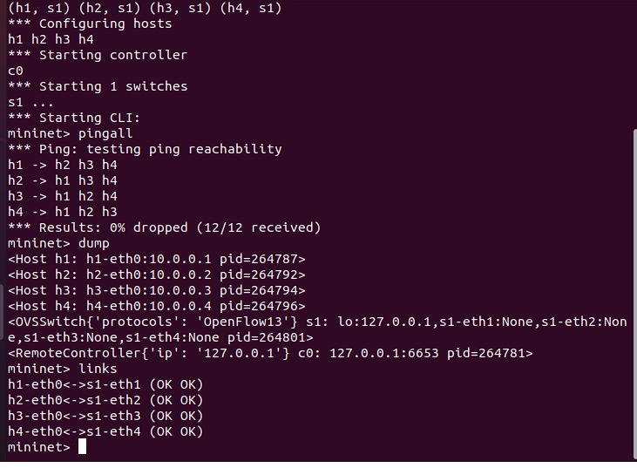

Controller and Openflow capture:

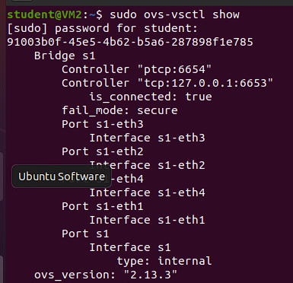



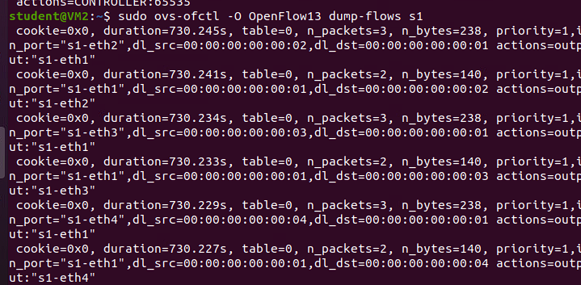

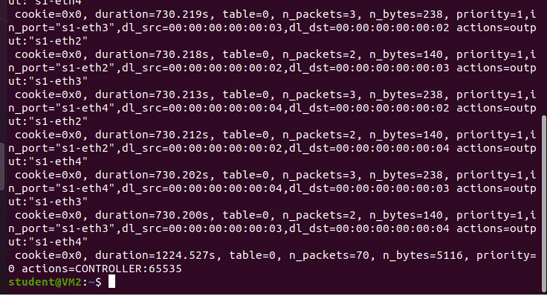

CONTINUE TO NEXT PAGE PLEASE

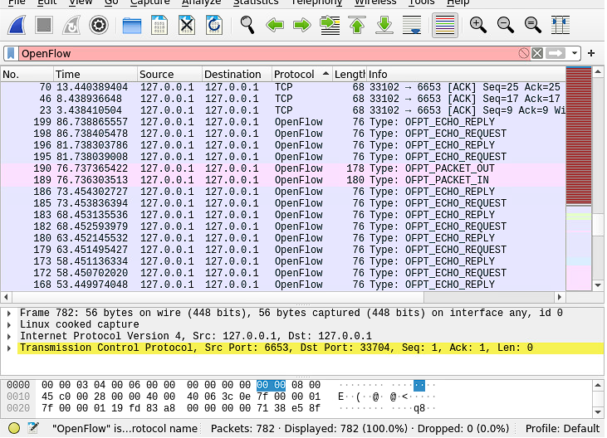

**Quick check on subnet knowledge: you have 2 VMs in vCloud as you created from template library. How can you identify from the ip that they are located in 2 different subnets?**

A: We can use the IP address of the VMs to identify which subnet they are located in by looking at the subnet mask. The subnet mask is used to divide the IP address into two parts: the network address and the host address. By comparing the subnet mask of each VM's IP address, you can determine which subnet they belong to. For example, if the subnet mask for one VM is 255.255.255.0 and the subnet mask for the other VM is 255.255.0.0, we can say that the first VM is located in a subnet with a smaller network and the second VM is located in a subnet with a larger network.